Chapter 8, Problem 78.

An automobile airbag igniter is modeled by the circuit in Fig. 8.122. Determine the time it takes the voltage across the igniter to reach its first peak after switching from A to B. Let R = 3 Ω, C = 1/30 F, and L = 60 mH.

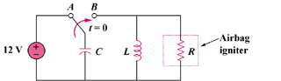

Figure 8.122
For Prob. 8.78.

